## Overview

Pushing your code to GitHub is the first step to having a publicly accessible webpage. In this activity, you’ll learn how to clone a GitHub repository, upload your code to GitHub, and publish your static webpage on GitHub Pages.

## Instructions

### **Part 1: Create a Repository (Repo)**

1. Go to [GitHub](https://www.github.com), click on the **+** icon in the upper-right corner and select **New Repository**.



1. Name your new repository My_First_Repo and select **Public**.
2. Click **Create repository**.

**Part 2: Clone Your Repository (Repo)** 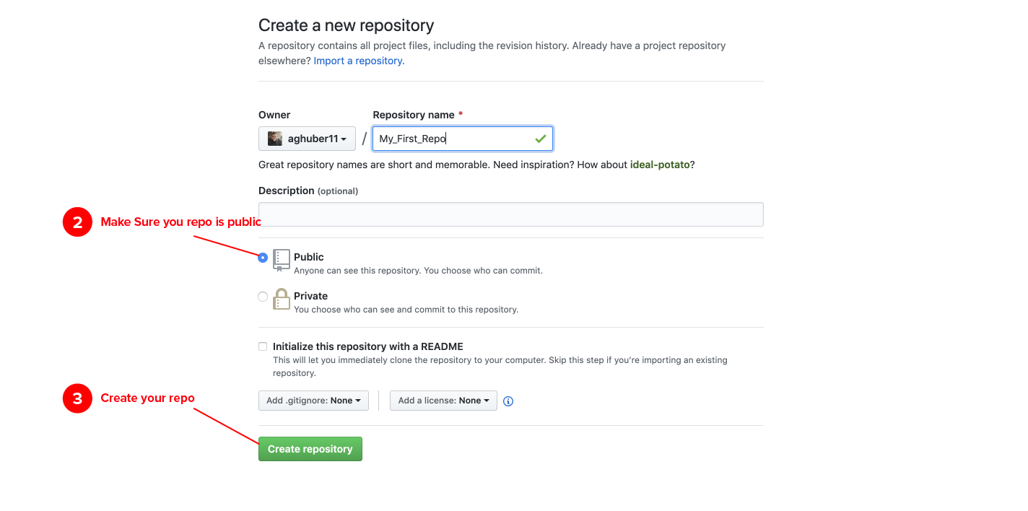

1. Open GitHub Desktop and log in using your GitHub account credentials.
   * You download GitHub Desktop [here](https://desktop.github.com/) if you haven’t already done so.
2. Under the drop-down menu, select **FILE > CLONE REPOSITORY**.

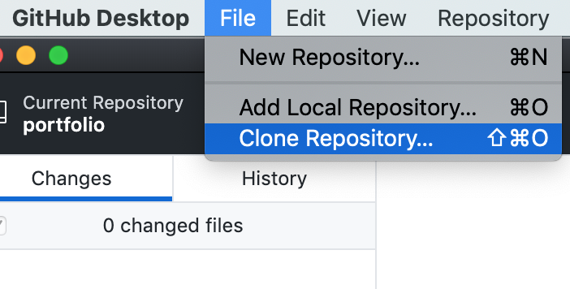

1. You should see this screen:

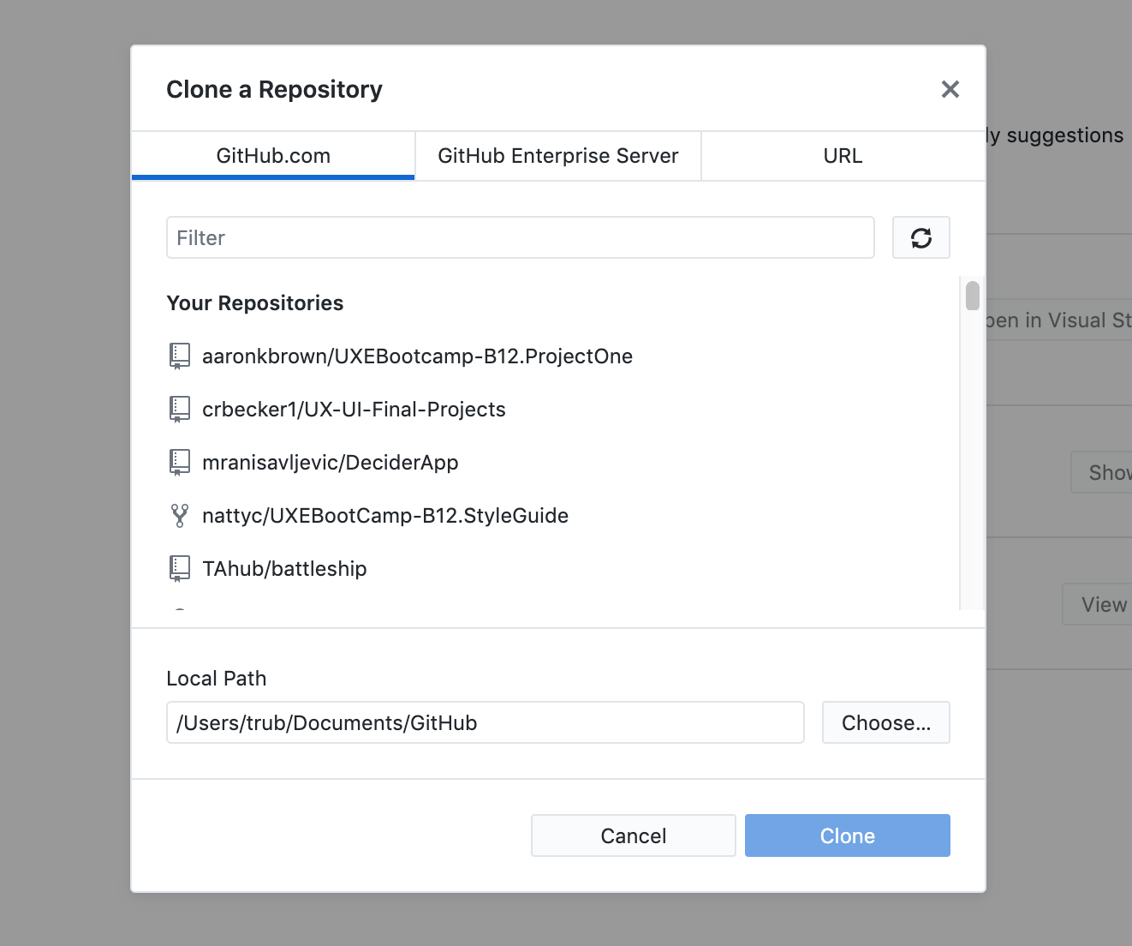

1. Press the refresh button so that GitHub can load the new repository you created.

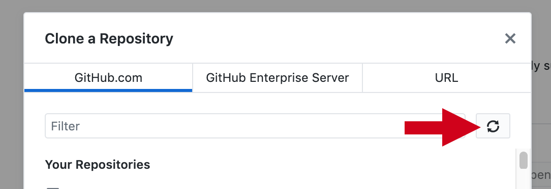



1. Choose a location on your computer to save a local copy of your repository. Make sure to choose a spot you will remember, then click **Clone**.

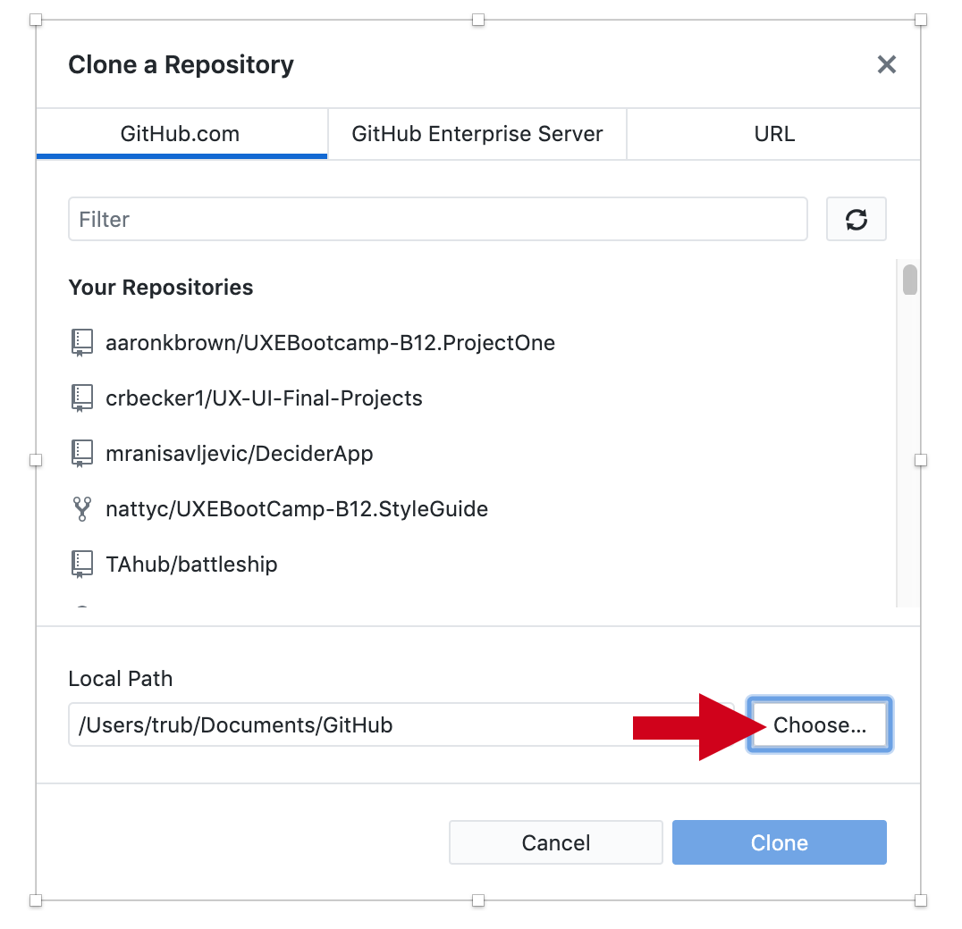

* + You’ll want to choose the **Documents/00_MyCode** folder. You will use this folder to keep all of your Repositories for the remainder of the class.

1. Now you need to add files to your new repository.
   * Your GitHub desktop page should look like this. Select the button **SHOW IN FINDER.**

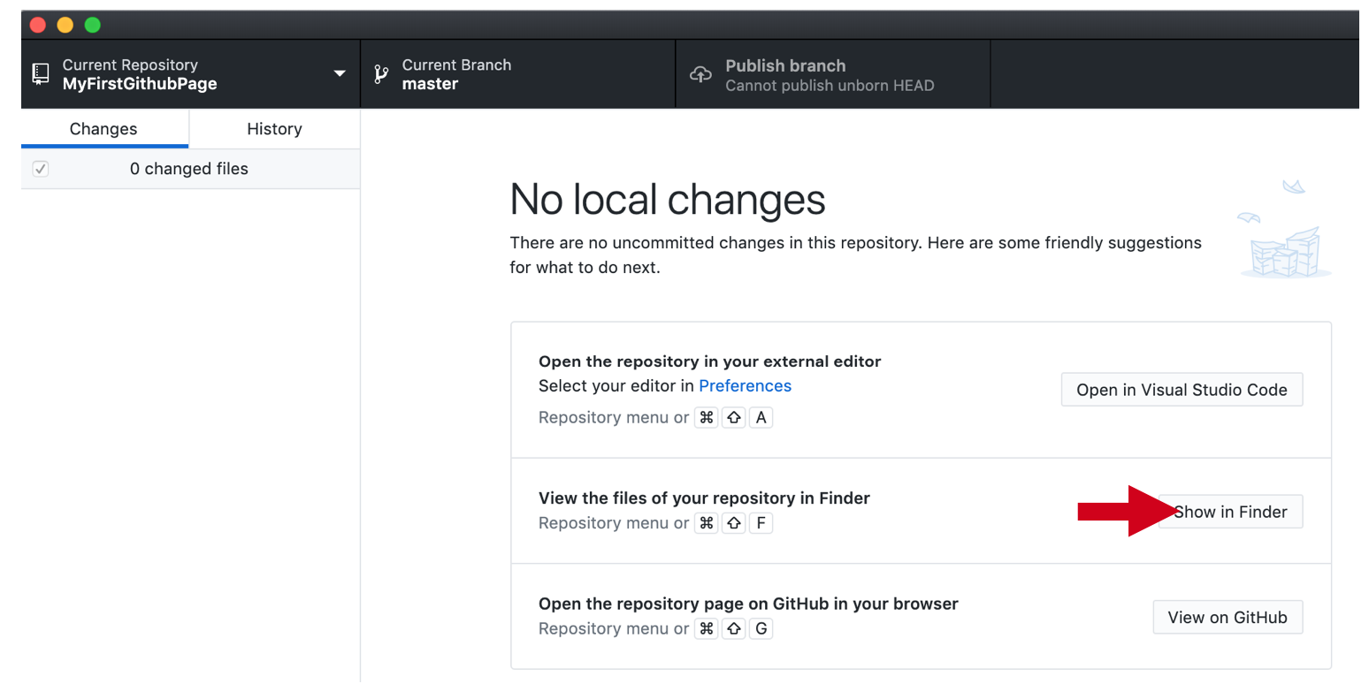

* + Congratulations! You have created your first repository and cloned it to your desktop.

Note: GitHub can sometimes take up to 15 minutes to make changes.